Minimax Algorithm in Game Theory | Set 1 (Introduction)
Minimax is a kind of backtracking algorithm that is used in decision making and game theory to find the optimal move for a player, assuming that your opponent also plays optimally. It is widely used in two player turn-based games such as Tic-Tac-Toe, Backgammon, Mancala, Chess, etc.
In Minimax the two players are called maximizer and minimizer. The maximizer tries to get the highest score possible while the minimizer tries to do the opposite and get the lowest score possible.
Every board state has a value associated with it. In a given state if the maximizer has upper hand then, the score of the board will tend to be some positive value. If the minimizer has the upper hand in that board state then it will tend to be some negative value. The values of the board are calculated by some heuristics which are unique for every type of game.
Example:
Consider a game which has 4 final states and paths to reach final state are from root to 4 leaves of a perfect binary tree as shown below. Assume you are the maximizing player and you get the first chance to move, i.e., you are at the root and your opponent at next level. Which move you would make as a maximizing player considering that your opponent also plays optimally?
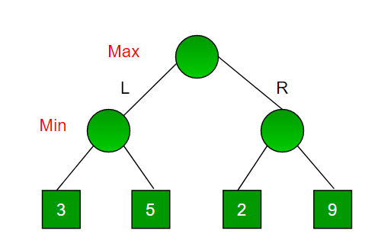

Since this is a backtracking based algorithm, it tries all possible moves, then backtracks and makes a decision.
- Maximizer goes LEFT: It is now the minimizers turn. The minimizer now has a choice between 3 and 5. Being the minimizer it will definitely choose the least among both, that is 3
- Maximizer goes RIGHT: It is now the minimizers turn. The minimizer now has a choice between 2 and 9. He will choose 2 as it is the least among the two values.
Being the maximizer you would choose the larger value that is 3. Hence the optimal move for the maximizer is to go LEFT and the optimal value is 3.
Now the game tree looks like below :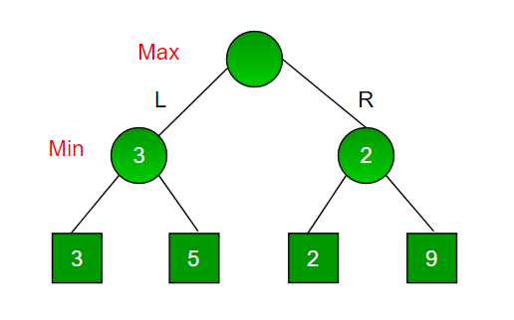The above tree shows two possible scores when maximizer makes left and right moves.
Note: Even though there is a value of 9 on the right subtree, the minimizer will never pick that. We must always assume that our opponent plays optimally.
Below is the implementation for the same.

C++
// A simple C++ program to find
// maximum score that
// maximizing player can get.
#include<bits/stdc++.h>
using namespace std;

// Returns the optimal value a maximizer can obtain.
// depth is current depth in game tree.
// nodeIndex is index of current node in scores[].
// isMax is true if current move is
// of maximizer, else false
// scores[] stores leaves of Game tree.
// h is maximum height of Game tree
int minimax(int depth, int nodeIndex, bool isMax,
int scores[], int h)
{
// Terminating condition. i.e
// leaf node is reached
if (depth == h)
return scores[nodeIndex];

// If current move is maximizer,
// find the maximum attainable
// value
if (isMax)
return max(minimax(depth+1, nodeIndex*2, false, scores, h),
minimax(depth+1, nodeIndex*2 + 1, false, scores, h));

// Else (If current move is Minimizer), find the minimum
// attainable value
else
return min(minimax(depth+1, nodeIndex*2, true, scores, h),
minimax(depth+1, nodeIndex*2 + 1, true, scores, h));
}

// A utility function to find Log n in base 2
int log2(int n)
{
return (n==1)? 0 : 1 + log2(n/2);
}

// Driver code
int main()
{
// The number of elements in scores must be
// a power of 2.
int scores[] = {3, 5, 2, 9, 12, 5, 23, 23};
int n = sizeof(scores)/sizeof(scores[0]);
int h = log2(n);
int res = minimax(0, 0, true, scores, h);
cout << "The optimal value is : " << res << endl;
return 0;
}

Java

C#

Python3
Output:
The optimal value is: 12
The idea of this article is to introduce Minimax with a simple example.
- In the above example, there are only two choices for a player. In general, there can be more choices. In that case, we need to recur for all possible moves and find the maximum/minimum. For example, in Tic-Tax-Toe, the first player can make 9 possible moves.
- In the above example, the scores (leaves of Game Tree) are given to us. For a typical game, we need to derive these values

Properties of Mini-Max algorithm:
- Complete- Min-Max algorithm is Complete. It will definitely find a solution (if exist), in the finite search tree.
- Optimal- Min-Max algorithm is optimal if both opponents are playing optimally.
- Time complexity- As it performs DFS for the game-tree, so the time complexity of Min-Max algorithm is O(b^{m}), where b is branching factor of the game-tree, and m is the maximum depth of the tree.
- Space Complexity- Space complexity of Mini-max algorithm is also similar to DFS which is O(bm).

What is the Minimax algorithm?
Minimax is a recursive algorithm which is used to choose an optimal move for a player assuming that the other player is also playing optimally. It is used in games such as tic-tac-toe, go, chess, Isola, checkers, and many other two-player games. Such games are called games of perfect information because it is possible to see all the possible moves of a particular game. There can be two-player games which are not of perfect information such as Scrabble because the opponent’s move cannot be predicted.
It is similar to how we think when we play a game: “if I make this move, then my opponent can only make only these moves,” and so on. Minimax is called so because it helps in minimizing the loss when the other player chooses the strategy having the maximum loss.

Terminology
- Game Tree: It is a structure in the form of a tree consisting of all the possible moves which allow you to move from a state of the game to the next state.
A game can be defined as a search problem with the following components:
- Initial state: It comprises the position of the board and showing whose move it is.
- Successor function: It defines what the legal moves a player can make are.
- Terminal state: It is the position of the board when the game gets over.
- Utility function: It is a function which assigns a numeric value for the outcome of a game. For instance, in chess or tic-tac-toe, the outcome is either a win, a loss, or a draw, and these can be represented by the values +1, -1, or 0, respectively. There are games that have a much larger range of possible outcomes; for instance, the utilities in backgammon varies from +192 to -192. A utility function can also be called a payoff function.

How does the algorithm work?
There are two players involved in a game, called MIN and MAX. The player MAX tries to get the highest possible score and MIN tries to get the lowest possible score, i.e., MIN and MAX try to act opposite of each other.
The general process of the Minimax algorithm is as follows:
Step 1: First, generate the entire game tree starting with the current position of the game all the way upto the terminal states. This is how the game tree looks like for the game tic-tac-toe.
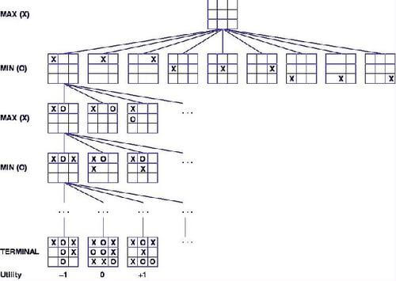
Let us understand the defined terminology in terms of the diagram above.
- The initial state is the first layer that defines that the board is blank it’s MAX’s turn to play.
- Successor function lists all the possible successor moves. It is defined for all the layers in the tree.
- Terminal State is the last layer of the tree that shows the final state, i.e whether the player MAX wins, loses, or ties with the opponent.
- Utilities in this case for the terminal states are 1, 0, and -1 as discussed earlier, and they can be used to determine the utilities of the other nodes as well.
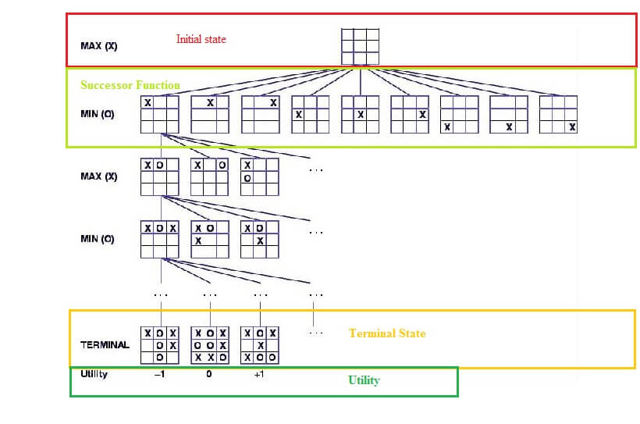
Step 2: Apply the utility function to get the utility values for all the terminal states.
Step 3: Determine the utilities of the higher nodes with the help of the utilities of the terminal nodes. For instance, in the diagram below, we have the utilities for the terminal states written in the squares.
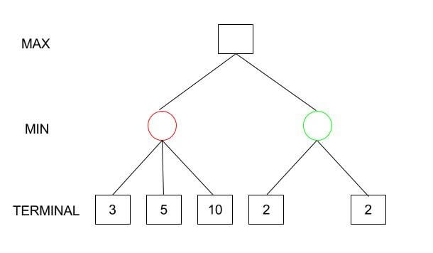
Let us calculate the utility for the left node(red) of the layer above the terminal. Since it is the move of the player MIN, we will choose the minimum of all the utilities. For this case, we have to evaluate MIN{3, 5, 10}, which we know is certainly 3. So the utility for the red node is 3.
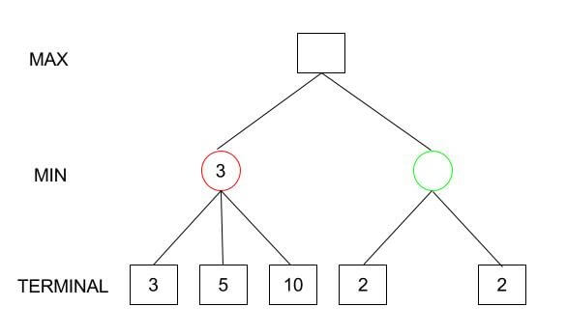
Similarly, for the green node in the same layer, we will have to evaluate MIN{2,2} which is 2.
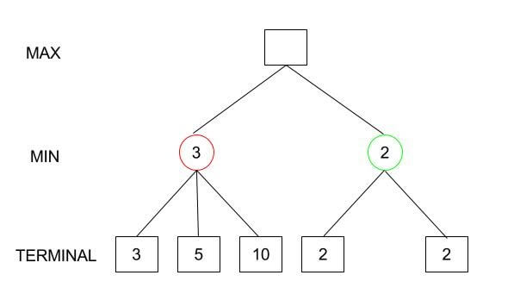
Step 4: Calculate the utility values with the help of leaves considering one layer at a time until the root of the tree.
Step 5: Eventually, all the backed-up values reach to the root of the tree, i.e., the topmost point. At that point, MAX has to choose the highest value.
In our example, we only have 3 layers so we immediately reached to the root but in actual games, there will be many more layers and nodes. So we have to evaluate MAX{3,2} which is 3.
Therefore, the best opening move for MAX is the left node(or the red one). This move is called the minimax decision as it maximizes the utility following the assumption that the opponent is also playing optimally to minimize it.
To summarize,
Minimax Decision = MAX{MIN{3,5,10},MIN{2,2}}
= MAX{3,2}
= 3
1  2  3  4  5  6  7  8  9  10  11  12  13  14  15  16  17 | function minimax(node, depth, maximizingPlayer)  if depth = 0 or node is a terminal node  return the utility of the node  if maximizingPlayer  bestValue := ??  for each child of node  v := minimax(child, depth ? 1, FALSE)  bestValue := max(bestValue, v)  return bestValue  else (* minimizing player *)  bestValue := +?  for each child of node  v := minimax(child, depth ? 1, TRUE)  bestValue := min(bestValue, v)  return bestValue

